**Hurst Street Cycling and Motorist Hazard**

Clearly a massive need to improve/rethink cycle lane markings in the city centre (thinking of Birmingham). Some are sufficiently unclear to both motorists and cyclists as to be dangerous. Hurst Street in Birmingham is a prime example. Starting at the intersection of Hurst Street and Bromsgrove Street and heading down the cycle lane on Hurst Street. Initially, the cyclist is directed against the flow of motorised traffic and immediately forced away from the left-hand side of the road, where there are typically parked vehicles, and into the flow of motorised traffic

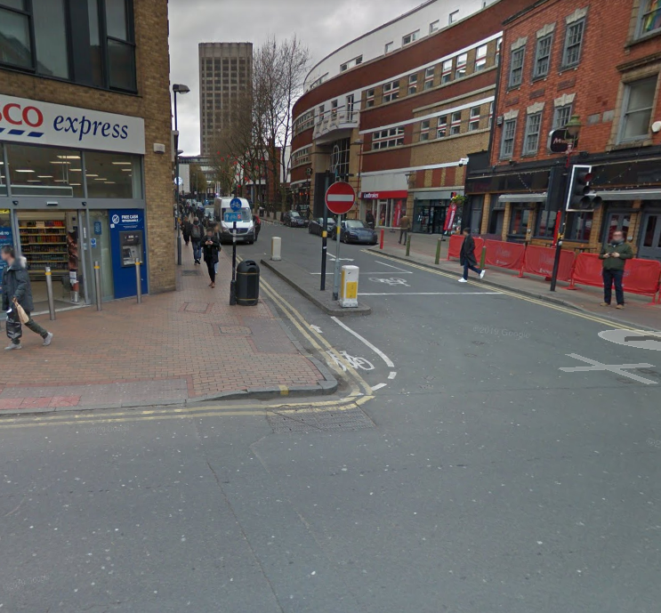

Further down the Hurst Street the cycle path continues into the pedestrian area to the right of the Hippodrome; this path cuts directly across the flow of motorised traffic on a sharp bend.

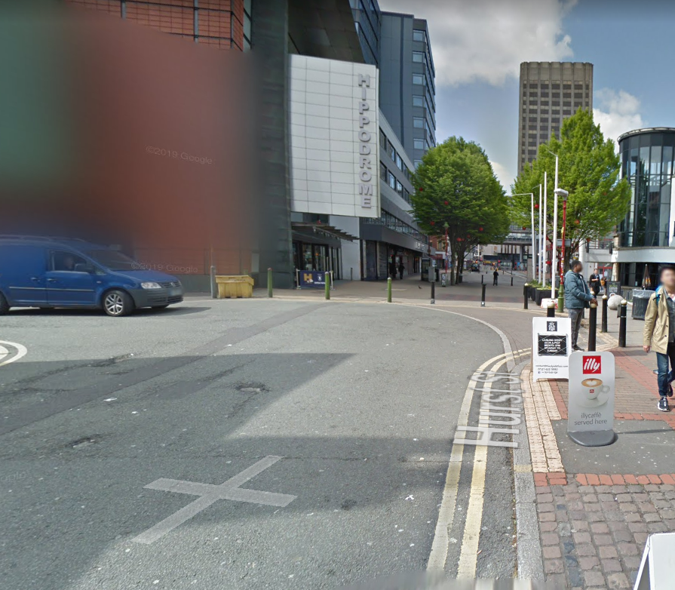

From the motorist’s perspective, heading to this bend from the opposite direction, there are no signs to indicate that cyclists may be emerging ahead. The only safe course of action for the cyclist is to get off on the pavement to the right-hand side prior to the bend and push their bikes to the pedestrian area. Needless to say, cyclists don’t do this.